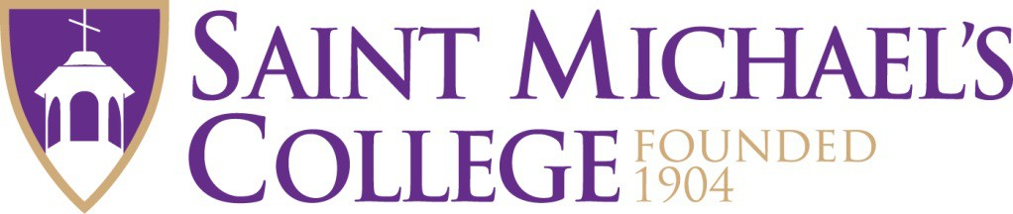

Alumni Association Board of Directors Job Description

*Updated 11.2.24*he Alumni Association’s Board of Directors serves as both a working board and an advisory group to understand the challenges facing the College. Board members are considered vital volunteers who go above and beyond for their alma mater when called upon.

The Board meets three times a year and its primary focus is to create and support programs and events that enhance the alumni experience. Members work on initiatives that provide Saint Michael’s alumni opportunities to engage with current students for career preparedness, to support enrollment initiatives, to build school pride, assist with fundraising, and be goodwill ambassadors for the College.

Saint Michael’s College Alumni Association Board of Directors consists of 24 voting members and most meetings are held on campus. One of the directors shall be a current student to better connect the Board to the student body. This representative will normally be named as an alumni board member upon graduation. Board members are expected to:

* Provide the College current contact information for fellow alumni with whom they have contact
* Provide information to the Office of Admission of prospective students they know
* Volunteer with the Career Education and Alumni Engagement Center either as a mentor, job shadow host, or Career Symposium panelist.
* Actively engage in the Alumni Connections LinkedIn group.
* Attend alumni events on campus or where you live; you may be asked to step in for staff members who are unable to attend as the SMC rep.
* Nominate candidates for the board and annual alumni awards
* Utilize social media account(s), if applicable, to share College news and campaigns
* Participate in SMC-sponsored service events as an Alumni Board representative
* Be an annual financial donor to the College (there are no giving minimums for members), with the goal of giving every year.
* Attend all board meetings. Your participation is key. If a board member misses three consecutive meetings, the Executive Committee reserves the right to dismiss that member.

Nominations for prospective directors are accepted throughout the year. Nominations turned in by December 31 will be taken into consideration for the new member term beginning July 1 of the following calendar year. If a nomination form is received after the December 31 deadline, the nomination may be held and considered for the following year.